**ONLINE SECURITY GAUARD HIRING SYSTEM**

**1. Introduction:**

**1.1 Project Overview:**

This project aims to develop a web-based platform that streamlines the hiring process for security guards. Online platform streamlines security guard hiring. Clients post requests, browse guard profiles, track applications. Guards create profiles, find jobs, apply, monitor status. Admin dashboard manages users, requests, and provides hiring insights. Simplifies recruitment, improves matching, and offers real-time transparency. Built with web technologies and prioritizes security and scalability.

**1.2 Objectives**:

* Simplify and speed up security guard hiring for both clients and guards.
* Enhance matching by connecting clients with qualified guards.
* Provide real-time transparency and centralized control through a user-friendly dashboard.

**2. Client Background:**

**2.1 Client Information:**

* The client is a management company overseeing multiple theater chains across various locations.
* They aim to enhance the ticket booking experience for moviegoers by offering an efficient and user-friendly online platform.
* The client seeks to increase ticket sales, streamline operations, and improve customer satisfaction through digital channels.

**3. Project Scope and Planning:**

* 1. **Scope Definition:**

1. **Client Module:**
   * Post hiring requests with details (location, duration, qualifications).
   * Browse guard profiles and filter based on needs.
   * Track application statuses and manage shortlisted guards (optional communication).
2. **Security Guard Module:**
   * Create profiles highlighting experience, certifications, and availability.
   * Search for open positions based on their qualifications.
   * Apply for relevant jobs and track application statuses.
   * (Optional) Communicate with interested clients.
3. **Admin Module:**
   * Manage user accounts (clients and guards).
   * Monitor all hiring requests (active, pending, rejected).
   * Review applications and approve/reject guards for positions.
   * Access a dashboard with key metrics (requests, guards, etc.).

**3.2 Technology Stack:**

**Front-End :** HTML, JavaScript, CSS, Bootstrap.

**Back-End** : PHP

**4. Development Process:**

**4.1 Front-end Development:**

Language Detector and Translator is developed using HTML & CSS as front-end.

**HTML:**

HTML (Hypertext Markup Language) is a markup language used to create and structure content on the web. It provides a standardized way to describe the structure and content of web pages, and is used in conjunction with other web technologies such as CSS (Cascading Style Sheets) and JavaScript.

HTML works by using a series of tags and attributes to define the different elements of a web page. These elements include headings, paragraphs, images, links, forms, and more. HTML code is written using a text editor, and can be viewed in any web browser.

**CSS:**

CSS (Cascading Style Sheets) is a styling language used to describe the visual appearance of web pages written in HTML or XML. It provides a way to separate the presentation of web content from the underlying structure, making it easier to make changes to the design without affecting the content.

CSS works by defining rules that apply to specific HTML elements. These rules specify how the element should be displayed, such as its font, color, size, and position. CSS can also be used to create layout and formatting styles, such as setting margins and padding, creating borders, and controlling the position of elements on the page.

CSS can be included in an HTML file using a <style> element in the <head> section, or it can be stored in a separate CSS file and linked to the HTML file using a <link> element in the <head> section. Multiple CSS files can be linked to a single HTML file, allowing for different styles to be applied to different parts of the page.

**4.2 Back-end Development:**

PHP is an open-source, interpreted, and object-oriented scripting language that can be executed at the server-side. PHP is well suited for web development. Therefore, it is used to develop web applications (an application that executes on the server and generates the dynamic page.).

PHP was created by Rasmus Lerdorf in 1994 but appeared in the market in 1995. PHP 7.4.0 is the latest version of PHP, which was released on 28 November. Some important points need to be noticed about PHP are as followed:

* + PHP stands for Hypertext Preprocessor.
  + PHP is an interpreted language, i.e., there is no need for compilation.
  + PHP is faster than other scripting languages, for example, ASP and JSP.
  + PHP is a server-side scripting language, which is used to manage the dynamic content of the website.
  + PHP can be embedded into HTML.
  + PHP is an object-oriented language.
  + PHP is an open-source scripting language.
  + PHP is simple and easy to learn language.

**5. Testing and Quality Assurance:**

**5.1 Testing Processes:**

**Functional Testing:**

* + 1. **Security Guard Module:**
* **User Registration and Login:**

Follow the same testing procedures as the Client Module.

* **Creating Guard Profiles:**

Verify successful profile creation with complete information (experience, certifications, availability).

Test uploading relevant documents (e.g., resume, certifications).

* **Searching for Jobs:**

Test searching and filtering job postings based on location, qualifications, and keywords.

Verify clear job details and application instructions.

* **Applying for Jobs:**

Test submitting applications for relevant positions.

Ensure attaching necessary documents (e.g., resume, cover letter) works as intended.

Verify tracking application statuses and receiving updates.

**2. Admin Module:**

* **User Management:**

Test creating, editing, and deleting user accounts (clients and guards).

Verify managing user roles and permissions.

* **Monitoring Hiring Requests:**

Ensure a complete list of all active, pending, and rejected hiring requests.

Test filtering and searching requests based on various criteria (date, location, status).

* **Reviewing Applications:**

Verify access to detailed applications with guard profiles and attached documents.

Test approving or rejecting applications for specific positions.

Ensure clear communication of decisions to both clients and guards.

* **Dashboard Functionality:**

Test displaying key metrics like total users, active requests, guard breakdown by status, etc.

Verify accurate data visualization in charts and graphs for easy comprehension.

Ensure ability to filter and drill down into specific data points if applicable.

**5.2 Debugging and Optimization:**

Debugging and optimization are critical phases in the development process of the Online Security Gauard Hiring System to ensure that the application functions efficiently, performs well, and delivers a seamless user experience including

**Debugging:**

* **Identify Issues:**
* Encourage user feedback through surveys or support channels to pinpoint problems.
* Monitor system logs for error messages or unexpected behavior.
* Conduct user testing to observe interaction patterns and identify pain points.
* **Common Issues and Solutions:**
  + **Registration/Login Issues:** Double-check user authentication processes and error messages.
  + **Profile Creation/Editing Issues:** Ensure validation rules are clear and data is saved correctly.
  + **Search/Filter Issues:** Verify filters work as intended and search algorithms are accurate.
  + **Communication Issues:** Test messaging functionality and notification systems.
  + **Dashboard Inconsistencies:** Validate data sources and ensure visualizations accurately reflect system data.

**Optimization:**

* **Performance Improvements:**
  + **Code Optimization:** Review code for inefficiencies and optimize for faster processing.
  + **Database Indexing:** Implement proper indexing on frequently used database fields.
  + **Caching Mechanisms:** Utilize caching to store frequently accessed data for quicker retrieval.
  + **Load Balancing (if applicable):** Distribute user traffic across multiple servers for better performance under high load.
* **User Interface (UI) and User Experience (UX) Optimization:**
  + **A/B Testing:** Conduct A/B testing to compare different UI layouts and functionalities to see which improve user engagement.
  + **Accessibility Testing:** Ensure the platform is accessible for users with disabilities.
  + **Intuitive Design:** Simplify navigation and make functionalities easily discoverable.
  + **Progress Indicators:** Provide clear visual cues for loading times and ongoing processes.

**6. Features and Functionality:**

This system aims to streamline the hiring process for security guards by offering features for both clients and security guards, managed through a centralized admin dashboard.

* + 1. **Client Features:**
* **User Registration and Login:** Create an account to access hiring functionalities.
* **Posting Hiring Requests:** Specify details like location, duration, qualifications, and pay rate.
* **Browsing Guard Profiles:** Search and filter profiles based on skills, experience, certifications, and location.
* **Shortlisting and Communication:** Select preferred guards and communicate directly (optional).
* **Application Tracking:** Monitor application statuses (pending, accepted, rejected) for all requests.
* **(Optional) Reviews and Ratings:** Leave feedback on the performance of hired guards (optional).
  + 1. **Security Guard Features:**
* **User Registration and Login:** Create an account to showcase their skills and experience.
* **Profile Creation:** Add details like experience, certifications, skills, availability, and resume upload.
* **Job Search:** Find open positions based on location, qualifications, and keywords.
* **Applying for Jobs:** Submit applications for relevant positions with optional cover letters.
* **Application Tracking:** Track the status of submitted applications and receive updates.
* **(Optional) Availability Calendar:** Manage availability and communicate scheduling preferences.
  + 1. **Admin Dashboard:**
* **User Management:** Create, edit, and manage user accounts (clients and guards).
* **Hiring Request Management:** View all active, pending, and rejected requests.
* **Reviewing Applications:** Access detailed applications with guard profiles and attached documents.
* **Approve/Reject Applications:** Make informed decisions on security guard suitability for positions.
* **Communication Tools:** Send notifications and announcements to relevant users (optional).
* **Dashboard Analytics:** View key metrics on users, requests, applications, hiring trends, and guard activity.

**7. Deployment and Launch:**

**7.1 Deployment strategy:**

1. **Choose a Deployment Environment:**
   * **Cloud Hosting:** Popular options like Google Cloud Platform (GCP), Amazon Web Services (AWS), or Microsoft Azure offer scalability and remote accessibility.
   * **On-Premise Hosting:** Consider this if you have specific security requirements or data privacy concerns. However, it requires managing your own hardware and software infrastructure.
2. **Prepare the System for Deployment:**
   * **Code Configuration:** Ensure the code is optimized for the chosen environment and configured for deployment.
   * **Database Setup:** Set up the database on your chosen platform and migrate any existing data (if applicable).
3. **Deployment Process:**
   * Follow the specific instructions for your chosen deployment environment. This typically involves uploading your code and database configurations.
4. **Testing and Validation:**
   * Perform thorough system testing in the deployment environment to ensure all functionalities work as expected.
   * Conduct security testing to identify and address any vulnerabilities before launch.

**7.2 Post-Launch Support:**

**1. Pre-Launch Marketing:**

* + **Target Audience:** Identify your ideal clients (businesses needing security guards) and security guards seeking employment.
  + **Marketing Channels:** Utilize social media, industry publications, or targeted online advertising to generate awareness.
  + **Landing Page Creation:** Build a landing page that captures leads, explains the platform's value proposition, and encourages early sign-ups.

1. **Controlled Launch:**
   * **Limited Beta Testing:**

Invite a small pool of potential clients and security guards to test the platform and provide feedback.

Use this feedback to identify and address any last-minute issues before a wider launch.

* + **Phased Rollout (Optional):**

Consider a gradual rollout by region or user type (clients first, then guards) to manage initial user load and address any unforeseen issues.

1. **Public Launch:**
   * **Official Announcement:** Announce the official launch through your marketing channels and notify pre-registered users.
   * **Ongoing Marketing & User Acquisition:** Implement ongoing marketing efforts to attract new users and maintain platform growth.

**8. Outcome and Results:**

**8.1 Project Results:**

The online security guard hiring system with a dashboard can potentially achieve a range of positive outcomes and results for both clients seeking guards and security guards themselves. Here's a breakdown of the potential benefits:

**For Clients:**

* **Reduced Time to Hire:** Streamlined hiring process allows clients to find qualified guards faster, minimizing the time it takes to fill open positions.
* **Improved Matching:** Search and filter functionalities based on skills, experience, and certifications help clients connect with guards who are a perfect fit for their needs.
* **Increased Efficiency:** Automating tasks like application tracking and communication reduces administrative burden and saves valuable time.
* **Cost Savings:** Faster hiring and reduced recruitment efforts can lead to overall cost savings.
* **Enhanced Transparency:** Real-time application status tracking keeps clients informed throughout the hiring process

.

**For Security Guards:**

* **Wider Job Opportunities:** Access to a broader range of security guard positions across various locations and industries.
* **Simplified Job Search:** Ability to easily search and apply for relevant jobs that match their qualifications.
* **Improved Visibility:** Profiles showcase their experience and skills to potential clients, increasing their chances of getting hired.
* **Faster Hiring Process:** Streamlined application process leads to quicker job placements.
* **Centralized Communication:** Platform facilitates communication directly with interested clients.

**Overall System Results:**

* **Increased User Base:** Growth in both the number of clients seeking guards and the number of security guards registered on the platform.
* **Improved Matching Efficiency:** Matching algorithms become more refined over time, leading to better connections between clients and guards.
* **Enhanced User Experience:** Ongoing optimization based on user feedback and data analysis creates a more user-friendly and efficient platform.
* **Market Growth:** The system can potentially contribute to the growth of the private security industry by facilitating a more efficient and transparent hiring process.

**Outcomes and Results:**

* **Marketing and User Acquisition Strategy:** The effectiveness of attracting both clients and security guards to the platform.
* **System Functionality and User Interface:** The ease of use, comprehensiveness of features, and overall user experience of the platform.
* **Data Security and User Trust:** The robustness of security measures and the level of trust established with users regarding data privacy.
* **Market Demand and Competition:** The overall demand for security guards and the presence of competing online hiring platforms.

**9. Conclusion:**

In conclusion, the online security guard hiring system with a dashboard streamlines recruitment for both clients and guards. Clients find qualified personnel faster, while guards access a wider job pool. Real-time tracking and a centralized admin dashboard ensure transparency and efficiency. This innovative platform has the potential to revolutionize the security industry by facilitating faster hiring, increased opportunities, and a more secure environment.

**10. References and Acknowledgments:**

* Upadhyaya, Sanjay, “Labour, Employment and Social Security Issues of Security Guards Engaged by Private Security Agencies: A Case Study of Okhla and Noida”, *NLI Research Studies Series*, No 093/2011, V.V. Giri National Labour Institute, Noida, UP, pp. 10–11[Google Scholar](https://scholar.google.com/scholar?q=Upadhyaya,+Sanjay,+%E2%80%9CLabour,+Employment+and+Social+Security+Issues+of+Security+Guards+Engaged+by+Private+Security+Agencies:+A+Case+Study+of+Okhla+and+Noida%E2%80%9D,+NLI+Research+Studies+Series,+No+093/2011,+V.V.+Giri+National+Labour+Institute,+Noida,+UP,+pp.+10%E2%80%9311)
* *Security Post*, [hereafter, *SP*], 16 (March–April 2010), cover page. *Security Post* is the newsletter of CAPSI & APDI (Association of Private Detective Agencies of India).
* “Course Curricula for Short Term Courses Based on Modular Employable Skills (MES) in Security Sector”, Directorate General of Employment and Training, Ministry of Employment and Labour, Government of India, [hereafter, DGET course], n.d., p. 2. Available from the DGET website: <http://dget.gov.in/mes/index.htm>; last accessed 18 April 2012.
* "Diminati Warga Profesi Satpam Tiap Tahun Meningkat[Attracted by Residents the Security Guard Profession Increases Every Year]", Redaksi, 02 2023, [online] Available: <https://jumalsecurity.com/diminati-warga-profesi-satpam-tiap-tahun-meningkat/#google_vignette>.

**11. Visuals:**

**Home Page:**

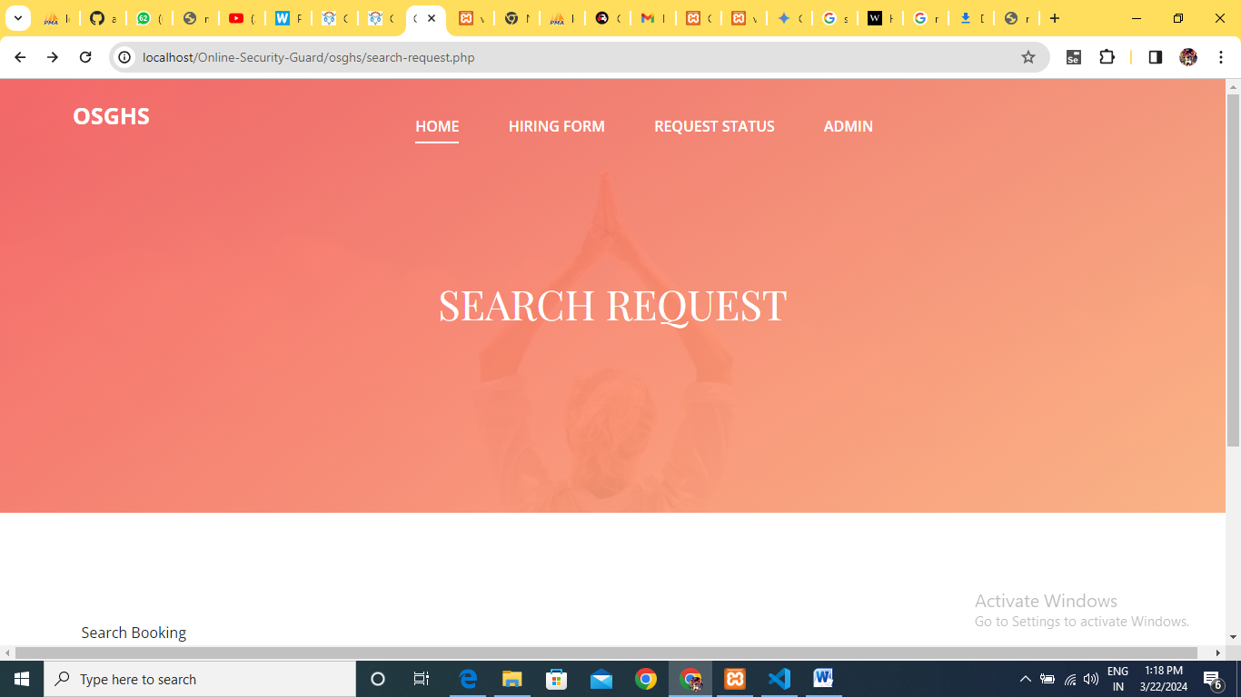

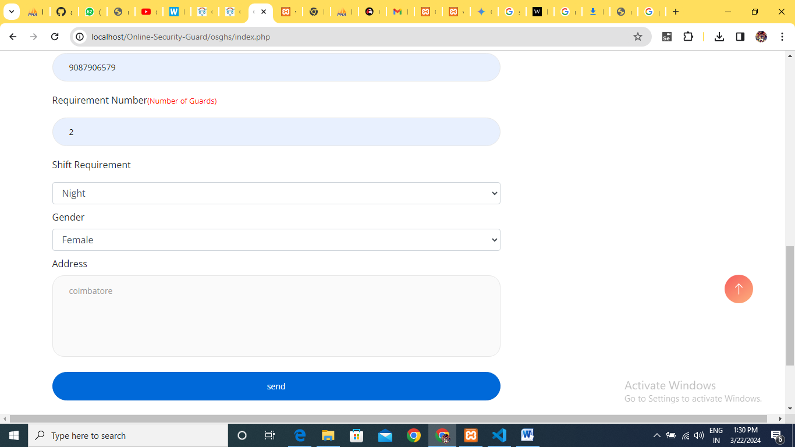

**Admin Login:**

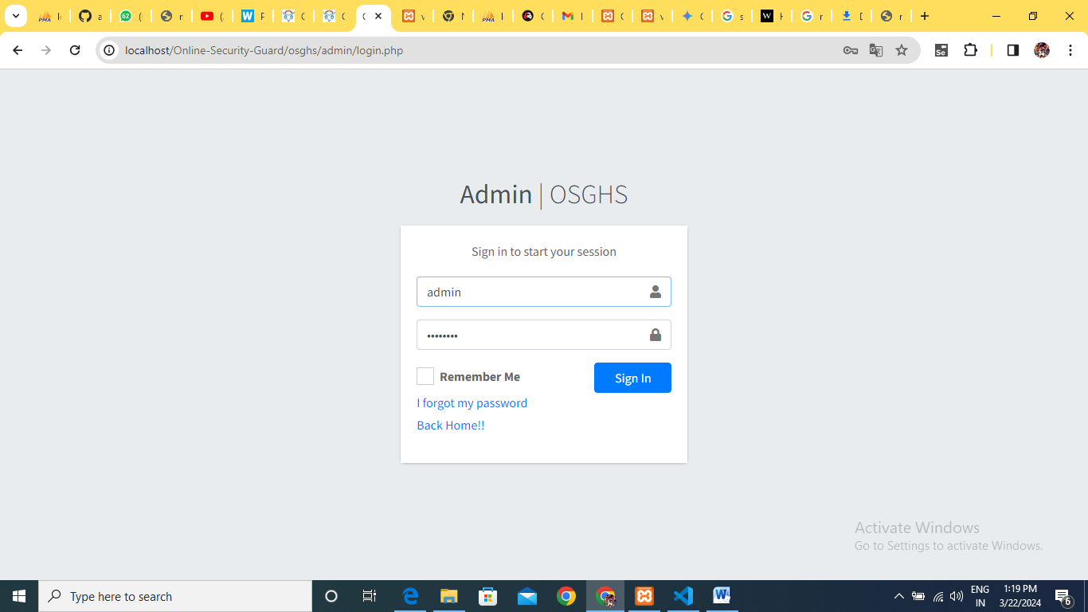

**Dashboard:**

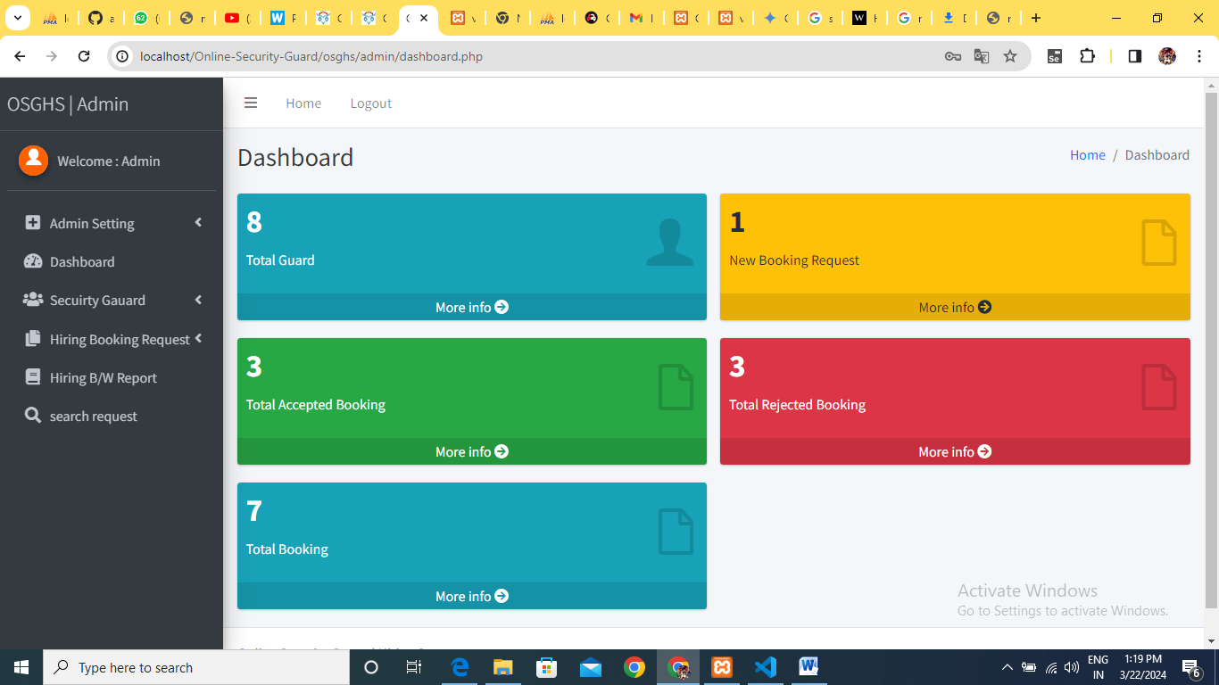

**BookingRequest**: 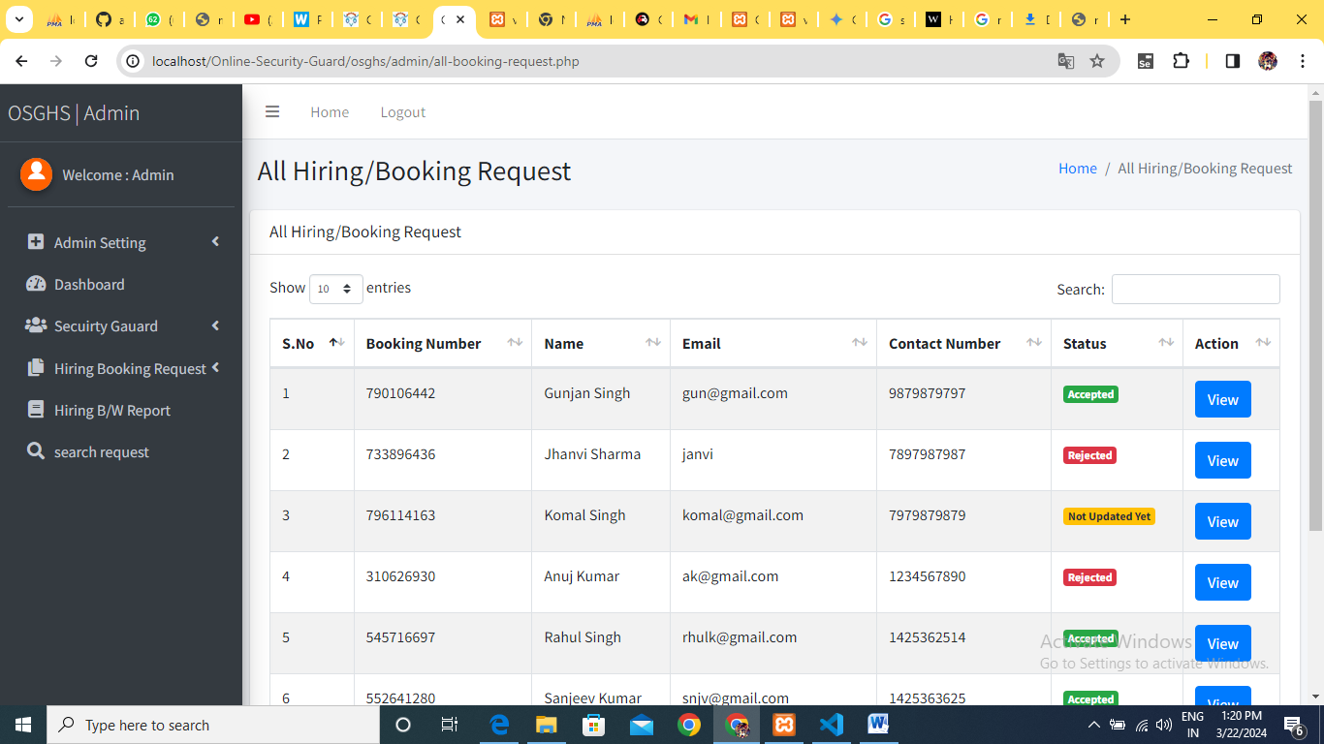

**AddSecurityGauard:** 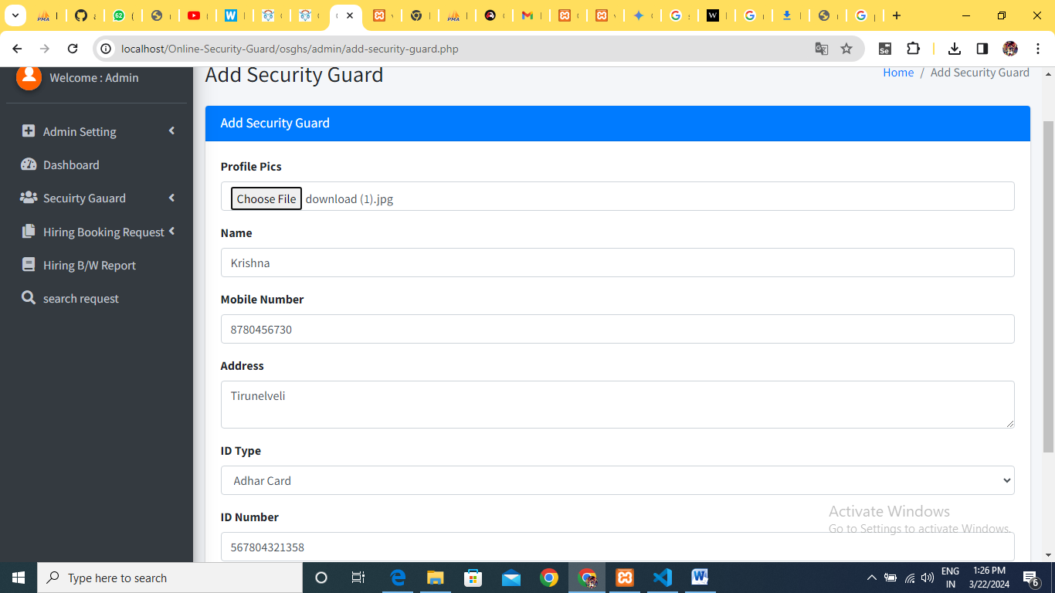

**UpdateSecurityGauard:**

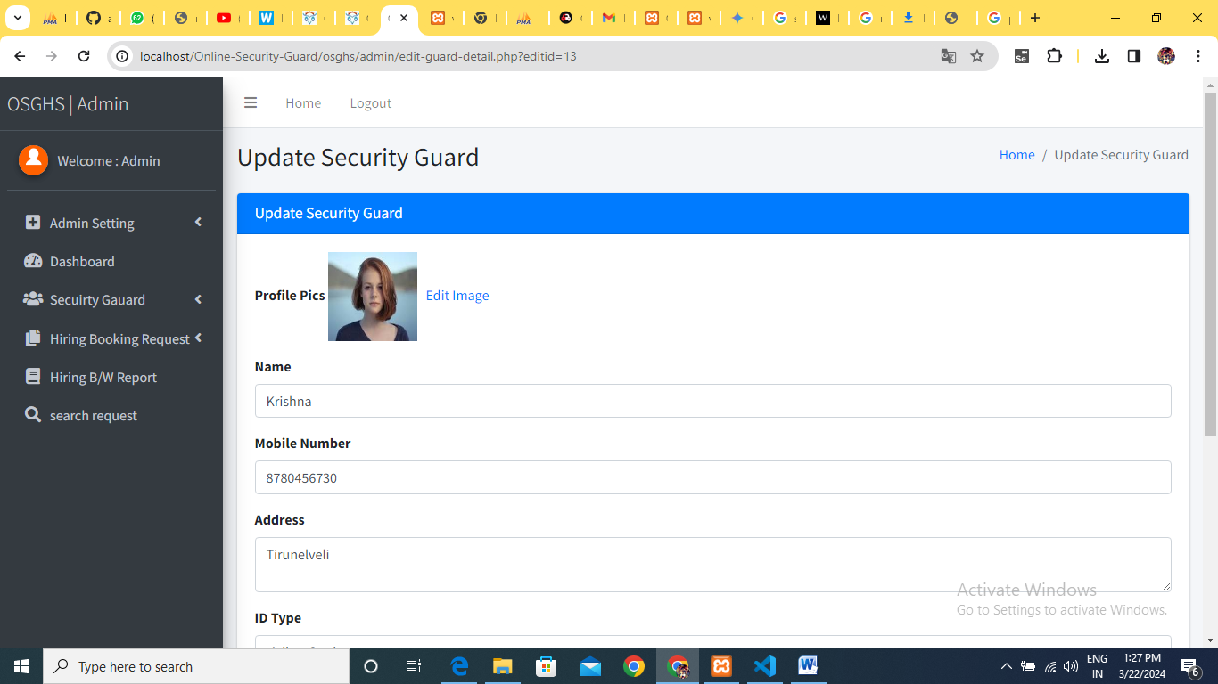

**SearchBooking:**

